
Dashboard Design

Date | 02 November 2026
Team ID | NA
Project Name | Electric Vehicle Market Performance & Insights
Maximum Marks | 5 Marks

Creating an effective dashboard involves thoughtful design to ensure that the presented information is clear, relevant, and easily understandable for the intended audience. Here are some key principles and best practices for dashboard design
Activity 1: Interactive and visually appealing dashboards
Creating interactive and visually appealing dashboards involves a combination of thoughtful design, effective use of visual elements, and the incorporation of interactive features. Here are some tips to help you design dashboards that are both visually appealing and engaging for users so take care of below points
- Clear and Intuitive Layout
- Use Appropriate Visualizations
- Colour and Theming
- Interactive Filters and Slicers
- Drill-Down Capabilities
- Responsive Design
- Custom Visuals and Icons
- Use of Infographics

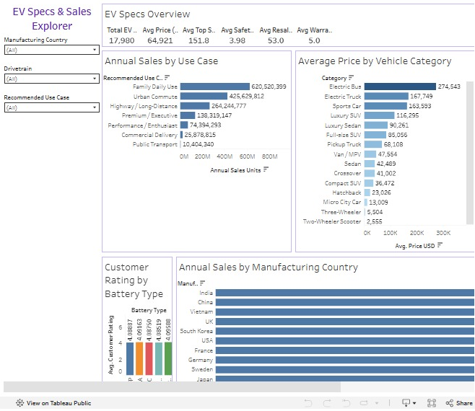
Key outcomes of the EV Specs & Sales Dashboard:
Five main outcomes:
- Family and city use drive sales: Family Daily Use (620.5 M units) and Urban Commute (425.6 M) together make up about two-thirds of EV sales.
- Huge price range: Average prices go from 2,555 USD for Two-Wheeler Scooters to 274,543 USD for Electric Buses.
- Battery type does not change ratings: Customer ratings stay between 4.085 and 4.096 for every battery chemistry.
- Balanced manufacturing: India and China lead with about 160 M units each, but all ten countries hold close to 10% of sales.
- Headline specs: 17,980 models, 64,921 USD average price, 151.8 km/h top speed, 3.98-star safety, 53.0% resale value after 3 years, 5.0-year warranty.
Overall: family and city use cases dominate EV sales, prices range from scooters to buses by a factor of about 100, battery chemistry does not change customer ratings and EV manufacturing is spread evenly across ten countries – answering the questions of Emily, David and Sarah.

Activity 2
Publish Dashboard on Tableau Public and Paste the Dashboard Public link below:
Dashboard public link:
[Paste Tableau Public dashboard link]

